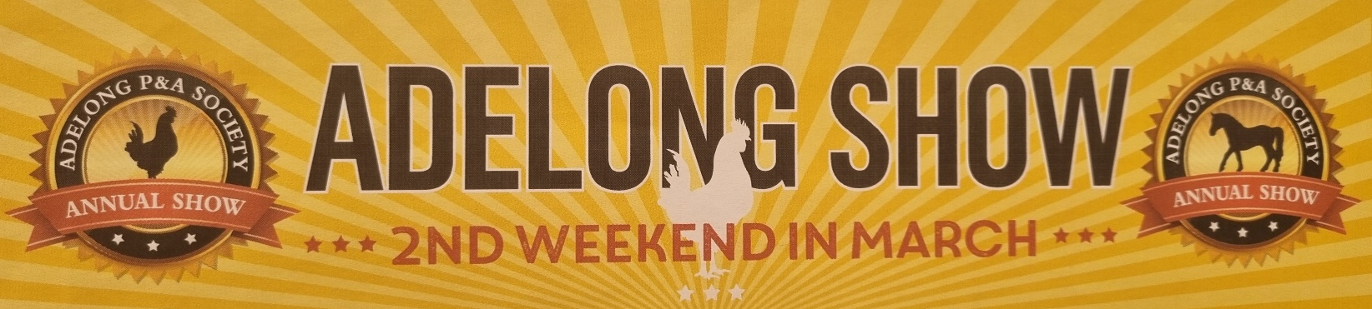
Adelong Show Schedule Cover Competition - 2027 Theme “NEXT GEN”
Draw us your best Next Gen picture for a chance to be the cover picture of the 2027 Show schedule!
Age categories: Pre-school (under 5 years), K-1-2, years 3-6, Years 7-12
Entries Close 11th November – Return all completed pictures to PO Box 35, Adelong or call for pick to Carolyn on 0477 524 123

